**Special operators**

Special operators in JS are a unary operators used to do specific functions, these operators are:

|  |  |  |
| --- | --- | --- |
| **Special Operators** | **sign** | **function** |
| **typeof Operator** | **Typeof () or typeof** | **Returns the type of a given operator** |
| **comma Operator** | **,** | **Returns the right operator** |
| **new Operator** | **new** | **Used to create a new instance for object** |
| **delete Operator** | **delete** | **Used to delete a property of an object.** |

**Examples: on type of operator.**

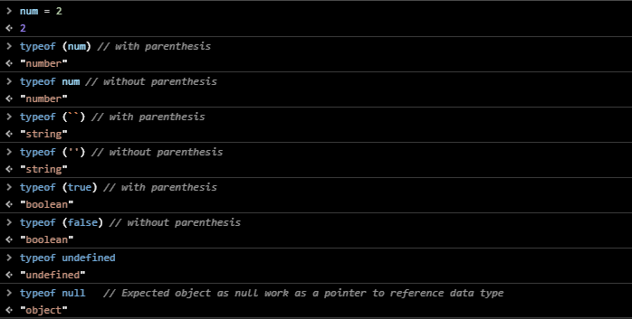

**Examples: on comma operator.**

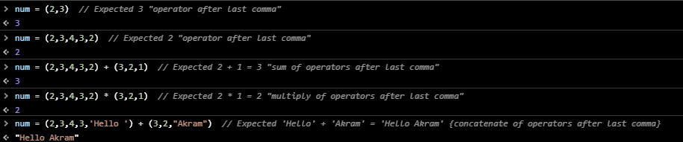

**Note:** parentheses () are very important as comma operator has a very low precedence so any other operator will execute **first** in case of Expressions.

**Example:** in the first example **( , , )** executes first then **=,** but in the second one = executes first then comma operator

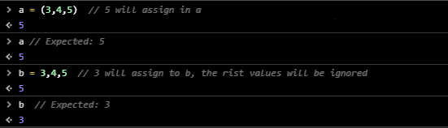

**Expected: on new operator**

**Expected: on delete operator.**

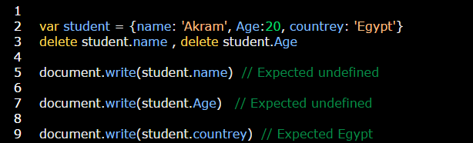

**Example: on delete operator.**

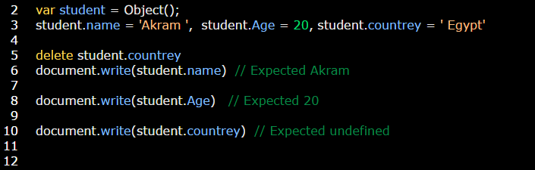

**Interview question:** how can get the first number in case of using comma operator.

**Answer:** use variable and comma operator **without parentheses**